PIZZA SALES SQL QUERIES

1. KPI’S
2. Total Revenue

Select SUM(total_price) AS Total_Revenue From pizza_sales

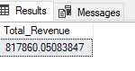

1. Average order value

Select Sum(total_price)/COUNT(DISTINCT order_id) AS Average_Order_Value from pizza_sales



1. Total Pizza Sold

Select SUM(quantity) AS Total_Pizza_Sold from pizza_sales

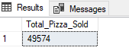

1. Total Order Placed

Select COUNT(Distinct order_id) AS Total_Order_Placed from pizza_sales

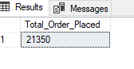

1. Average pizza’s sold per order

SELECT

CAST(CAST(SUM(quantity) AS DECIMAL(10, 2)) / CAST(COUNT(DISTINCT order_id) AS DECIMAL(10, 2)) AS DECIMAL(10,2)) AS Average_pizza_per_order

FROM pizza_sales;

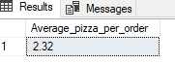

1. Percentage of total sales by pizza category

SELECT

pizza_category,

SUM(total_price) AS TotalSales,

(SUM(total_price) * 100.0) / SUM(SUM(total_price)) OVER () AS Percentage Of TotalSales

FROM pizza_sales where month(order_date)=3

GROUP BY pizza_category;

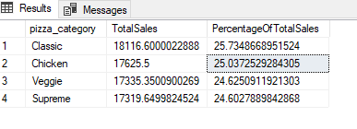

1. Daily trend of Pizza sales

Select DATENAME(DW,order_date) as order_day, COUNT(DISTINCT order_id) AS Total_Ordrer from pizza_sales

GROUP BY DATENAME(DW,order_date);

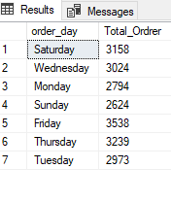

1. Monthly trend of Pizza Sales

Select DATENAME(MONTH, order_date) AS Month_Name, COUNT( DISTINCT order_id) AS Total_Order from pizza_sales

GROUP BY DATENAME(MONTH, order_date)

ORDER BY Total_order DESC;

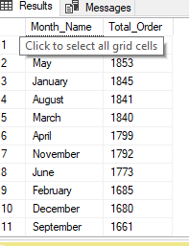

1. Percentage of sales by pizza size.

SELECT pizza_size, ROUND (SUM(total_price),2) AS Total_Sales,

ROUND((SUM(total_price)*100) /SUM(SUM(total_price)) OVER (),2) AS Percentage_of_Total_Sales FROM pizza_sales

GROUP BY pizza_size;

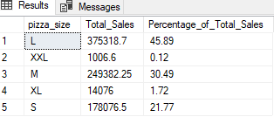

1. Top 5 Pizza by Quantity

SELECT TOP 5 pizza_name , SUM(quantity) AS Total_Quantity from pizza_sales

GROUP BY pizza_name

ORDER BY Total_Quantity DESC;

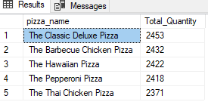

1. Top 5 Pizza by Orders

SELECT TOP 5 pizza_name , COUNT(DISTINCT order_id) AS Total_Order from pizza_sales

GROUP BY pizza_name

ORDER BY Total_Order DESC;

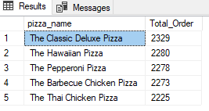

1. Top 5 Pizza by Revenue

SELECT TOP 5 pizza_name , SUM(total_price) AS Total_Revenue from pizza_sales

GROUP BY pizza_name

ORDER BY Total_Revenue DESC;

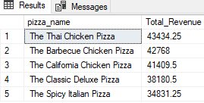

1. Bottom 5 Pizza by Revenue

SELECT TOP 5 pizza_name , SUM(total_price) AS Total_Revenue from pizza_sales

GROUP BY pizza_name

ORDER BY Total_Revenue ASC;

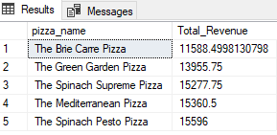

1. Bottom 5 Pizza by Quantity

SELECT TOP 5 pizza_name , SUM(quantity) AS Total_Quantity from pizza_sales

GROUP BY pizza_name

ORDER BY Total_Quantity ASC;

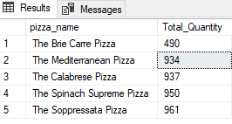

1. Bottom 5 Pizza by Orders

SELECT TOP 5 pizza_name , COUNT(DISTINCT order_id) AS Total_Orders from pizza_sales

GROUP BY pizza_name

ORDER BY Total_Orders ASC;

